ML LAB 2- Demonstrate various data pre-processing techniques for a given dataset
import pandas as pd
df=pd.read_csv('housing.csv')
df

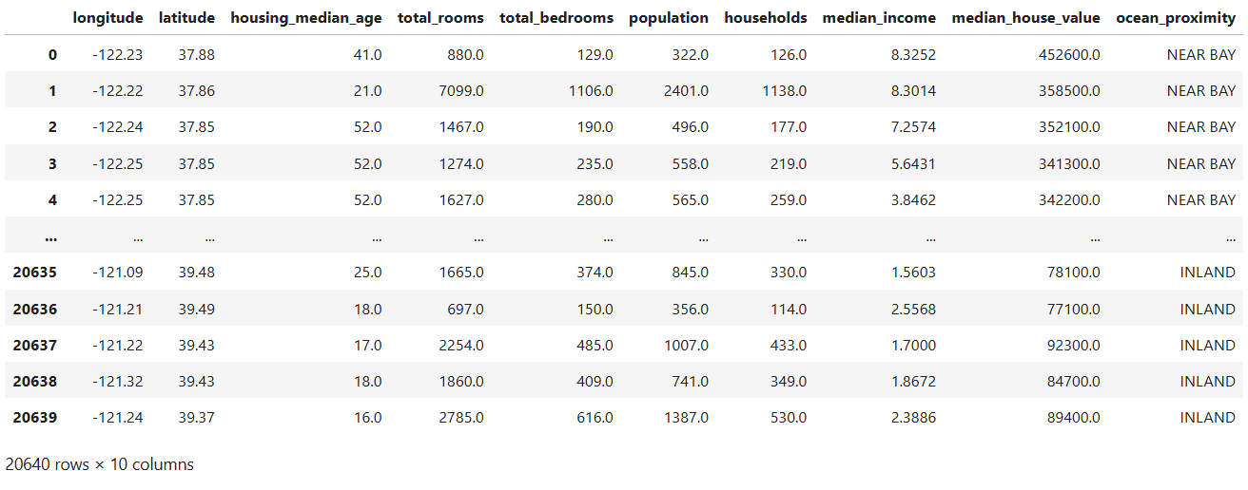

- Perform the describe and info steps

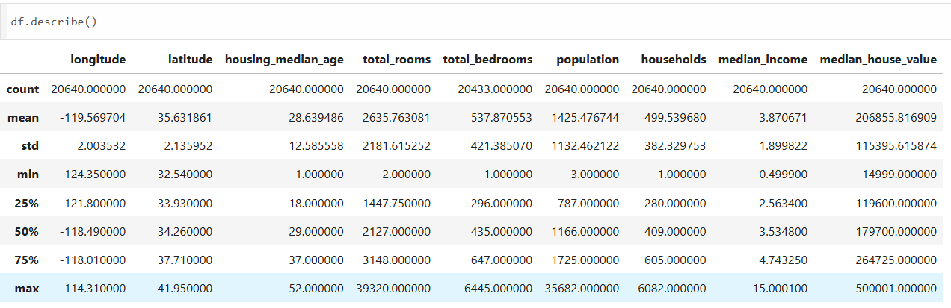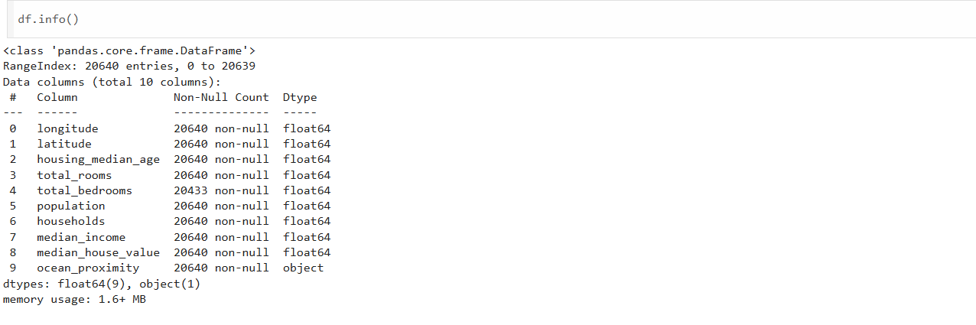
- Plot the histogram of each feature( Indicate what does histogram indicate on median_income and house_median_age)
import matplotlib.pyplot as plt
df.hist(bins=50, figsize=(20,15))
plt.show()
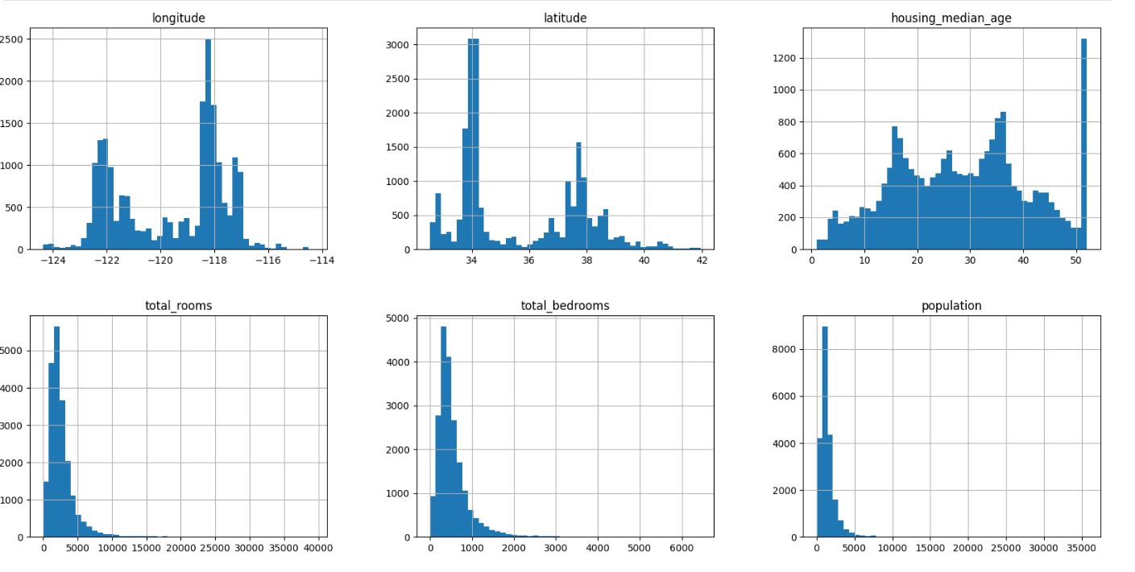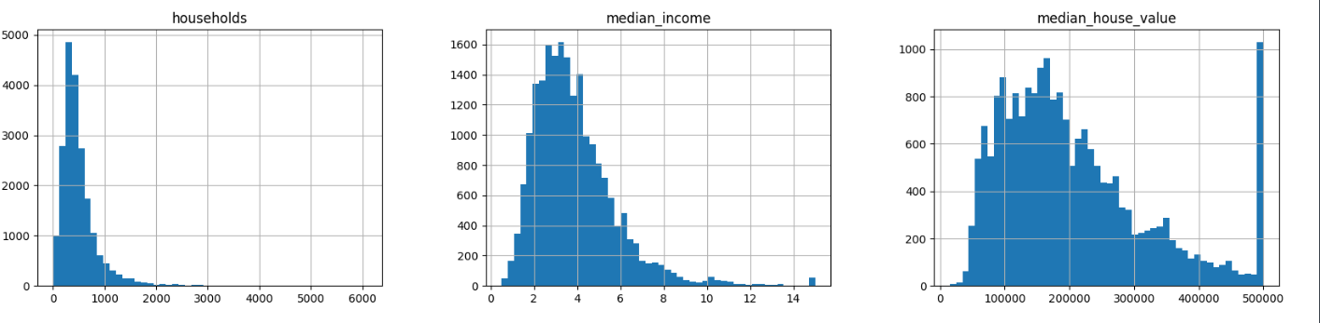
- Demonstrate the process of creating a test set( write the difference between random and stratified test set)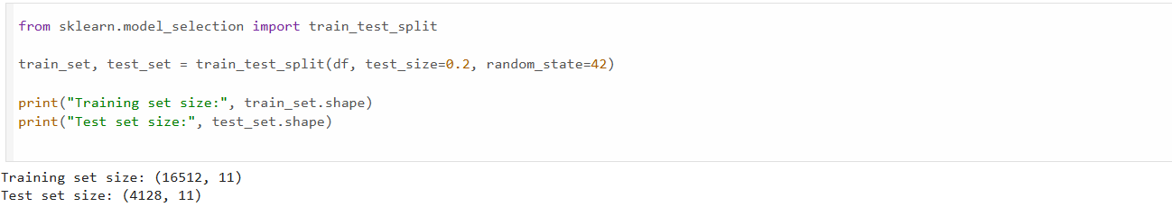
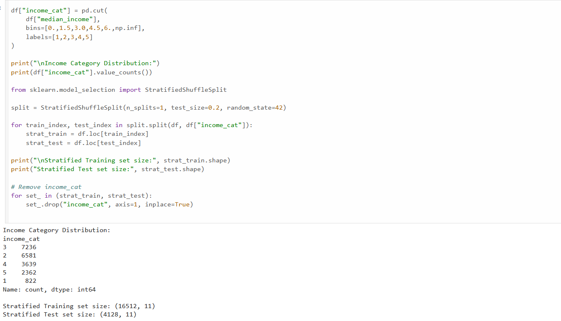

- List the geographical features from the dataset and plot a graph to Visualize Geographical Data(what does the graph indicate w.r.t housing prices and location)

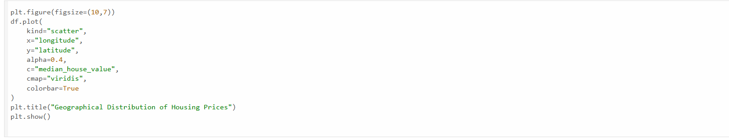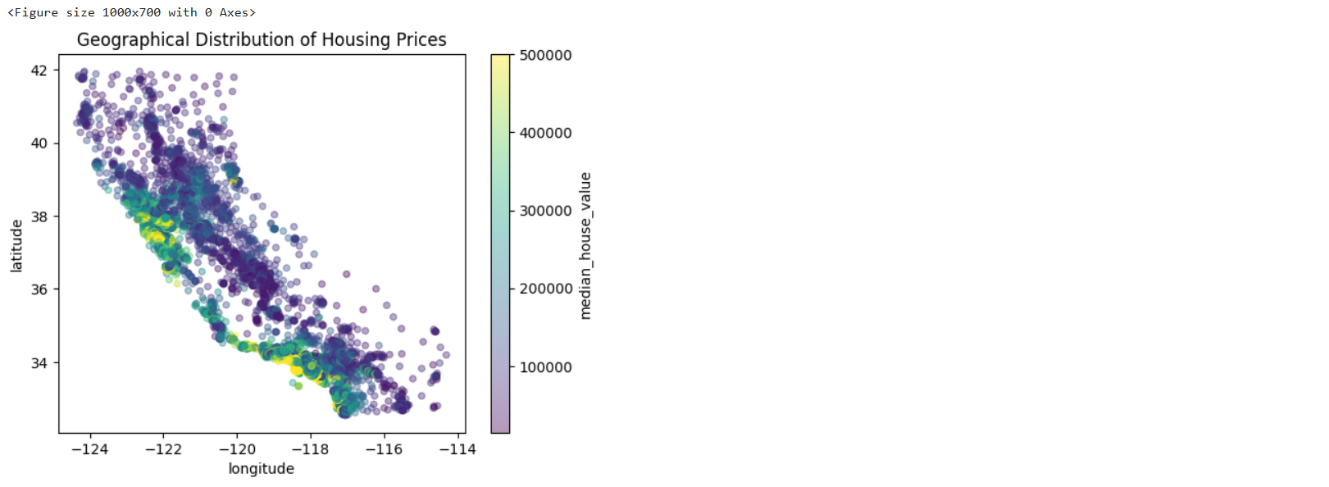
Expensive houses cluster near coastal regions. Location strongly impacts price.

- Plot a graph to show features correlation with housing price. Which feature corelates to the maximum. Plot the graph for that with housing price and analyze what the graph indicates

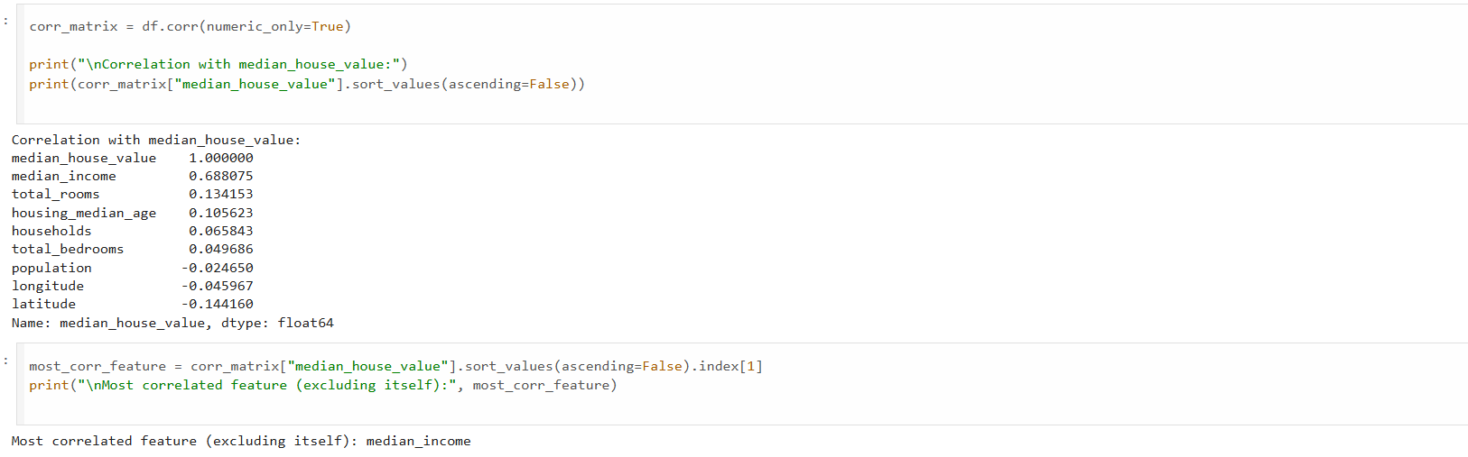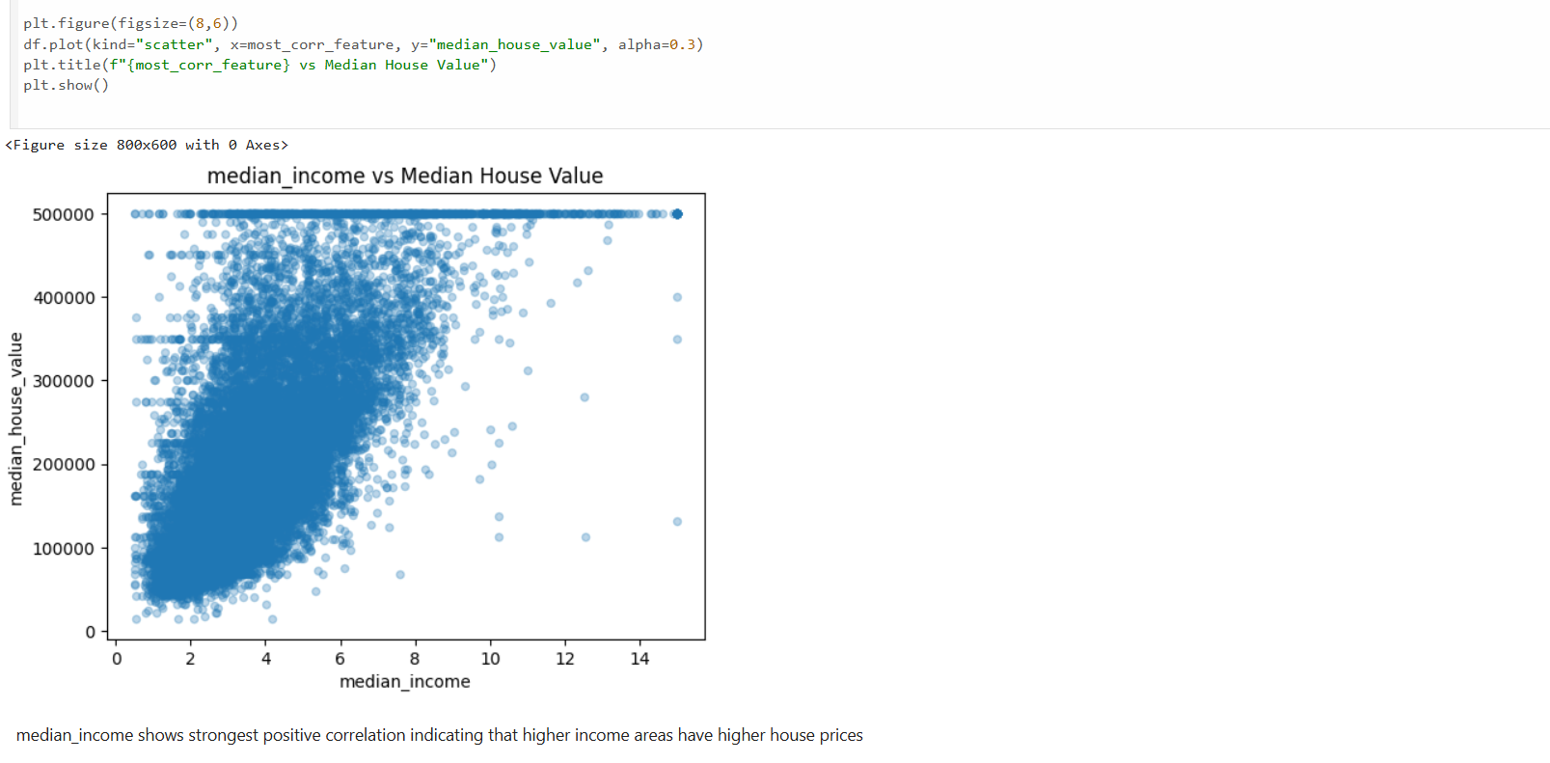
6. List the features that could be combined to improve correlation and plot again to see if correlation has improved
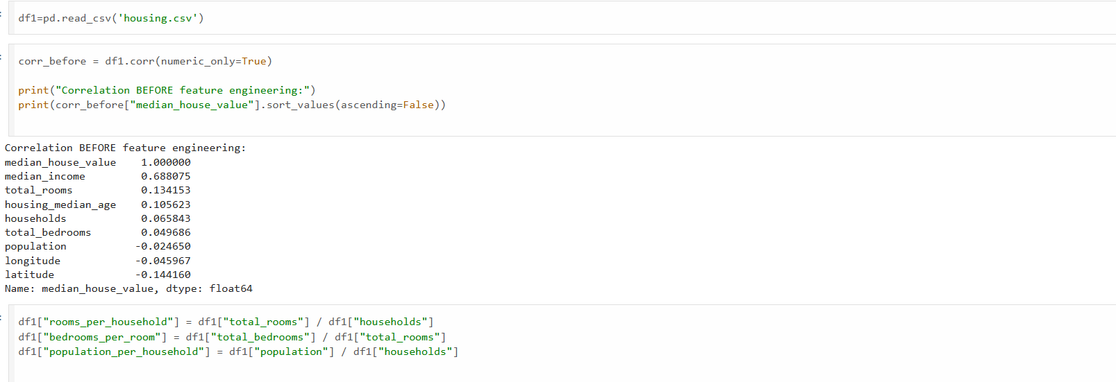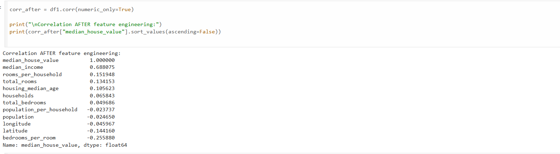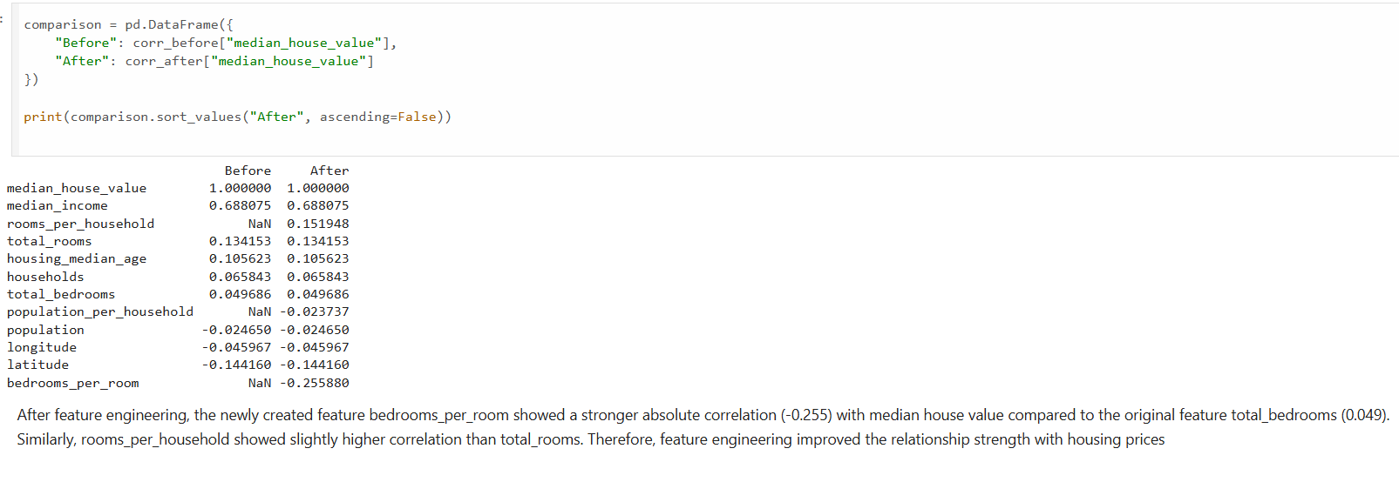
7. List the features that needs to be cleaned and demonstrate the process of cleaning
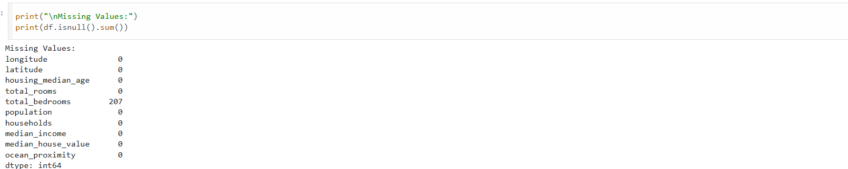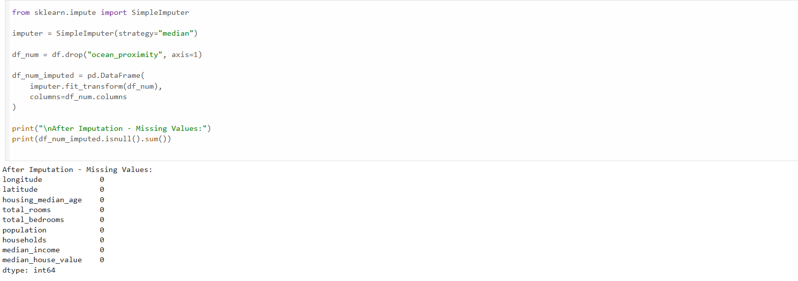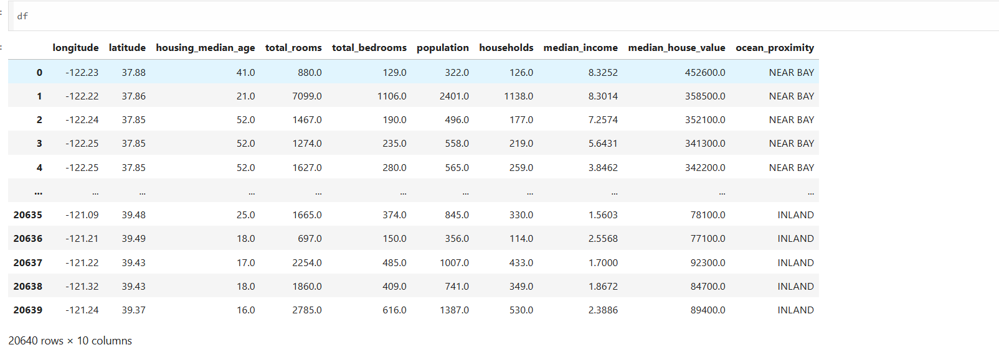
8. Is there any categorical data that needs to be converted to numerical? If so explain the method used to convert and code the same and show the output.
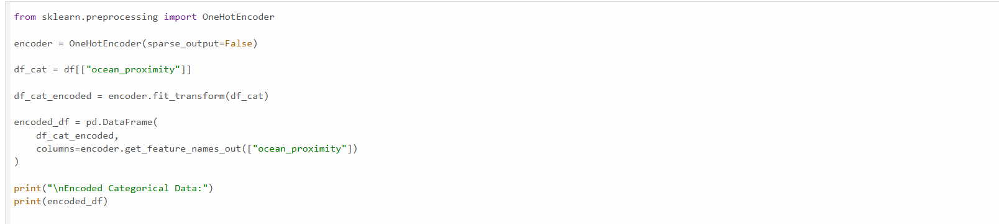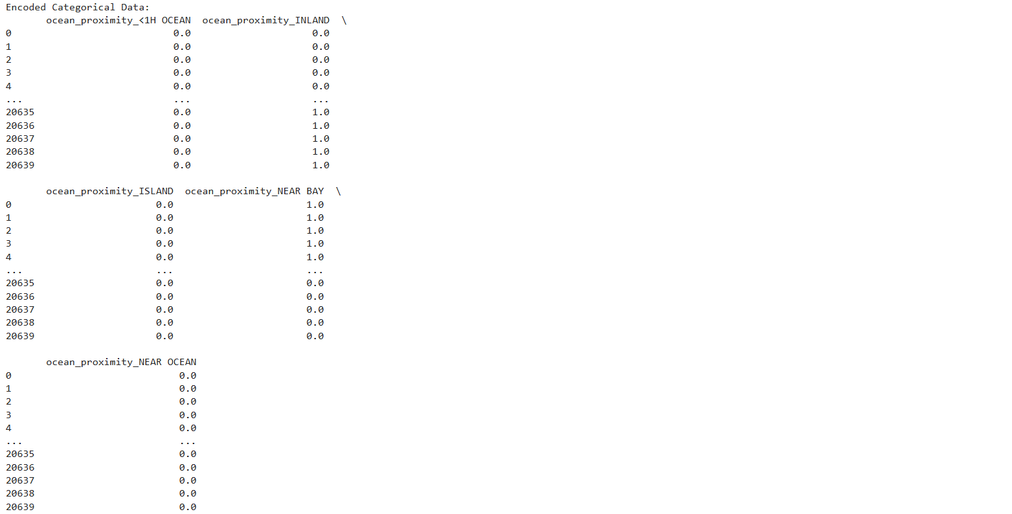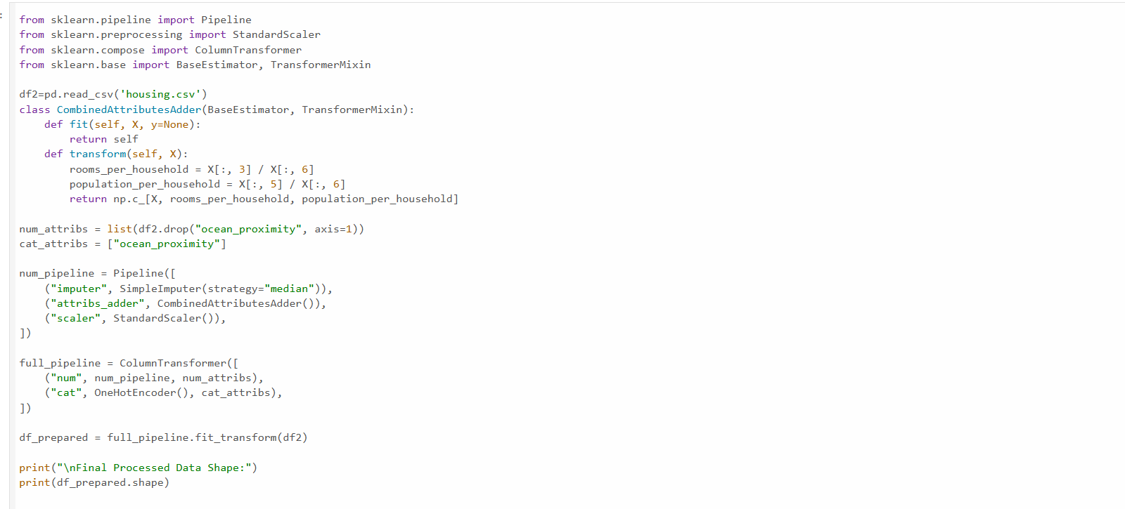
9. Discuss the importance of feature scaling
Prevents domination of large-value features. Required for Gradient Descent, SVM, KNN. Improves model convergence speed.

10. Design a pipeline inculcating (Custom transform, feature scaling and encoding). Explain how it works
